CENTRAL OTAGO HERITAGE TRUST - MEMBERSHIP FORM
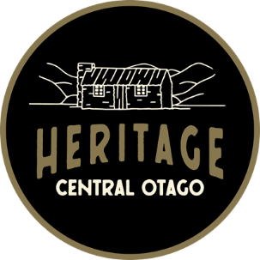
Thank you for your interest in becoming a member of the Central Otago Heritage Trust. Please complete the form below so we can find out more about your organisation and identify how we may help you achieve your heritage goals.
New members are formally confirmed at our Annual Meetings, however we look forward to working with you once your membership form has been accepted at our next bi-monthly Board meeting.

YOUR CONTACT DETAILS
Name of organisation
Physical address of organisation
Postal Address
(If different from above)
Website:
Key contact Person
Name:
Email:
Phone:

ABOUT YOUR ORGANISATION
How long has your organisation been operating?
What is your organisation structure?
What is the main purpose of your organization?
How many members does your organisation currently have?
What are your organisation’s key areas of interest regarding heritage?
(e.g., education, arts, preservation, oral history, heritage celebration)
What projects are your organisation currently working on that have a heritage element or focus?
Are there any specific areas or issues your organisation would like assistance with?

Please return the completed the form by email to: info@heritagecentralotago.org.nz or post to:
Central Otago Heritage Trust
34 Sunderland St
Clyde

